**Introduction**

**Wrong-way driver warning** is a new advanced driver-assistance system introduced in 2010 to prevent wrong-way driving. In the case of signs imposing access restrictions, through the wrong-way driver warning function an acoustic warning is emitted together with a visual warning in the instrument cluster – making an effective contribution towards helping to prevent serious accidents caused by wrong-way drivers.

Wrong-Way Driver Warning (WWDW) is based on road sign recognition & warning alert technology. The information about the car location provided by the on-board navigation system is also used. A forward camera behind the windshield recognizes important traffic signs (for example, speed limit, no parking etc.) along the car’s route & transfers the same to the dashboard or projection display.

**What is Wrong Way Alert?**

Wrong-Way Alert is the only wrong way driving solution designed to retrofit on existing signage. Wrong-Way Alert raises driver awareness in dangerous “wrong-way driver” situations.  The system is affordable, scalable, and designed for quick retrofit installation. Wrong-Way Alert consists of  *System Expandable*components which can be purchased separately as needed.

**Wrong-Way Alert *System Expansion & Upgrades***

The WWA system is a highly advanced Wrong Way warning system that can be logically designed to accommodate the various specific needs and challenges of each application. 4g Cell technology integrates for automatically alerting law enforcement or traffic safety personnel via SMS or email, that a wrong way incident is occurring, in real-time.

Highway on and off-ramps come in all shapes and sizes. Because of the extreme danger caused by inadvertent wrong-way drivers in these situations, an alert system has been needed which can easily be adapted to the particular roadway design. Our wireless controller and collaborator pairs have been designed to activate simultaneously and communicate with one another within milliseconds.  Each controller or collaborator has a D2D range of up to 2000’ in ideal conditions. The range can be extended via strategic placement since the units pass along network communications until they reach the intended units. This adaptability can allow the network to “see” around obstacles and terrain in complicated on or off-ramp situations. The mesh-net architecture allows for many configurations.

**System Expansion Options:**

**Back-Lit, Ring Enhanced Wrong Way and Do Not Enter Signs**

* Outstanding display performance pairs industry-standard reflective material with revolutionary internal illumination.
* Highly efficient.
* Proprietary illumination provides even, overall lighting of the sign to provide exceptional warning in any lighting scenario.

**Components of the WWA *System*:**

**High Intensity LED Enhancement Rings**

* Flush Mounted Enhancement Bars quickly mount on existing Wrong Way signage with permanent bonding tape and/or optional mechanical fasteners
* Sealed, potted unit
* Fully MUTCD compliant, sign shape is fully maintained even if several LEDs are physically damaged

**Controller Unit**

* Optional detection of the wrong-way driver using doppler radar
* The unit can be located anywhere within the detection zone (dictated by configuration utility setup)
* Mesh-Net System – Allows immediate Collaboration with remote devices tied into the system
* Accepts 12V input from AC transformer or Solar supply (AC power highly recommended)
* Fast 4g Cellular Modem delivers full video notification in an average of 10 seconds
* HD Resolution IP Camera

**Collaborator Unit**

* *Collaborates* detection of the wrong-way driver using synced doppler radars
* The unit can be located anywhere on-ramp within 4 detection zones (dictated by configuration utility setup)
* Mesh-Net System – Allows immediate Collaboration with remote devices tied into the system
* Solar or AC options available
* Flashing output configurable to several flash patterns and frequencies

**Tools, Software and Keywords used**

MATLAB, Simulink, MBD - Model-Based Development, Test Coverages, Auto-Code Generation, Model Checker and Advisor, ISO 26262 safety, WWDW.

**Aim**

To design a Simulink model for few of features of Wrong-Way Driver Warning System(WWDW). Details regarding the function of features are described in the given Requirement Document. Simulink Model includes Simulink model and Data Dictionary.

**Methodology**

**Given -**

Requirement document: Wrong-Way_Driver_Warning_Detection_Requirement.docx with 14 requirements guidelines from OEM.

**Step 1:** Studying all the parts of the requirement document provided, also called as requirement analysis.

Requirement Analysis is the first step in designing any model for a feature. Requirement sheet containing information regarding WWDW, function requirements and feature description is provided. Requirement sheet itself explains in detail about how the WWDW works.

**Requirement Document Analysis -**

Requirement Analysis is the first step in designing any model for a feature. Requirement sheet containing information regarding WWDW features, functional requirements and feature description is provided. Requirement sheet itself explains in detail about how the WWDW works. Various key points can be drawn from the requirement sheet which is necessary for designing the model for the system. Overall component systems or subsystems included in WWDW is explained with the help of Function Architecture. It shows the flow of information from various sensors to the Driver

Information Display. Requirement Document also includes details regarding input/output signals to be used while designing the model and its parameters like data type, size etc. At the end of Requirement Document, function requirement of features to be designed are mentioned. There are 14 requirements which need to satisfy while designing the model.

Function Requirement 1 – Input Signal Processing 1

Function Requirement 2 – Input Signal Processing 2

Function Requirement 3 –Input Signal Processing 3

Function Requirement 3 –Input Signal Processing 3

Function Requirement 4 – Input Signal Processing 4

Function Requirement 5 – Input Signal Processing 5

Function Requirement 6 – Input Signal Processing 6

Function Requirement 7 –Input Signal Processing 7

Function Requirement 13-Input Signal Processing 8

Function Requirement 14 -Input Signal Processing 9

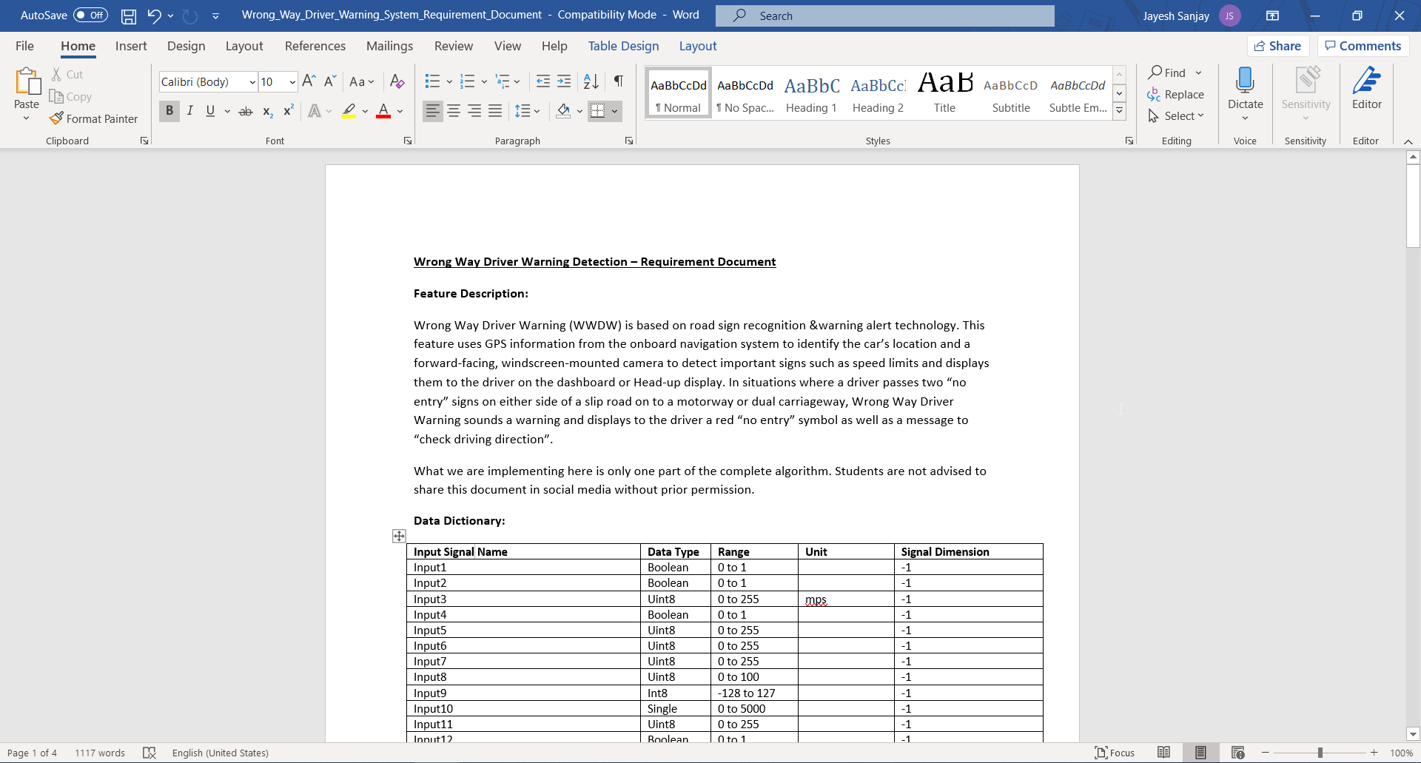

**Step 2:** Modelling according to the requirement document

After studying all requirements of feature from the requirement sheet, the next step is to design the Simulink model based on these points. Firstly, a skeleton model is designed. It consists of a subsystem cotaining all inputs and outputs of the system.

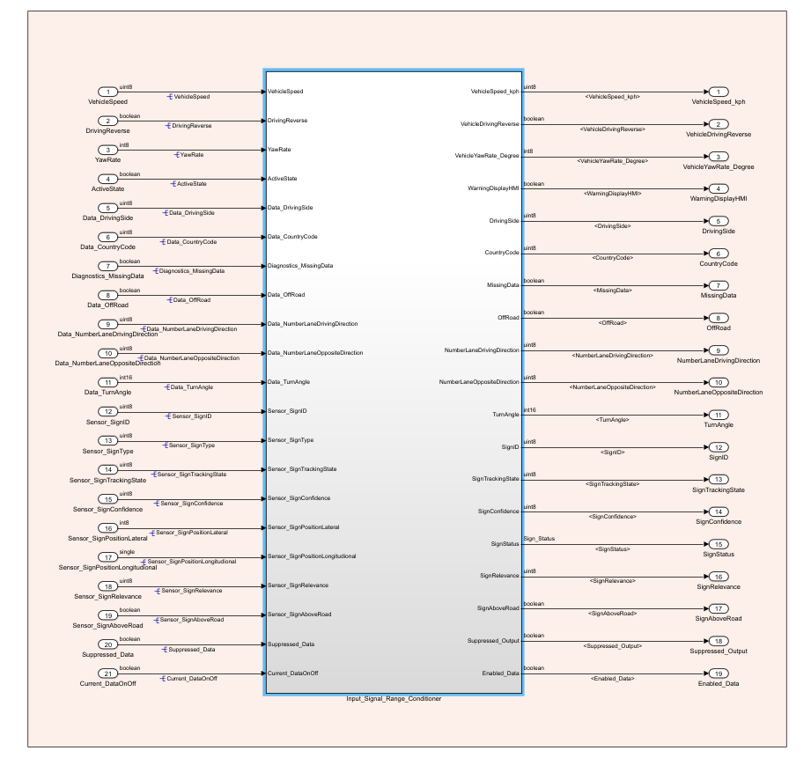

Above is the skeleton model of the system. It consists of 21 inputs and 19 output signals. This Subsystem is named a Input_Signal_Range_Conditioner. It consists of many other subsystems as per the requirement of features.

Inside this main subsystem, a view is below

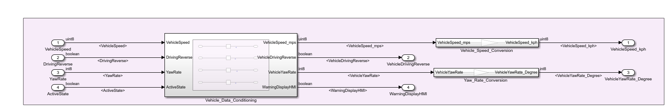

There are 9 subsystems under the main subsystem. These subsystems are created as per function requirements.

For satisfying function requirements FUN – REQ – 00001/2/3 following 3 substems are created.

 As per the first function requirement, signals: VehicleSpeed, DrivingReverse, YawRate, ActiveState needs to be renamed without any processing. This requirement is satisfied with subsystem Vehicle_Data_Conditioning. In between import and outport, a slider gain block with value 1 is placed. Value 1 didn't interfere with the input signal but it facilitates renaming the signal as per requirement.

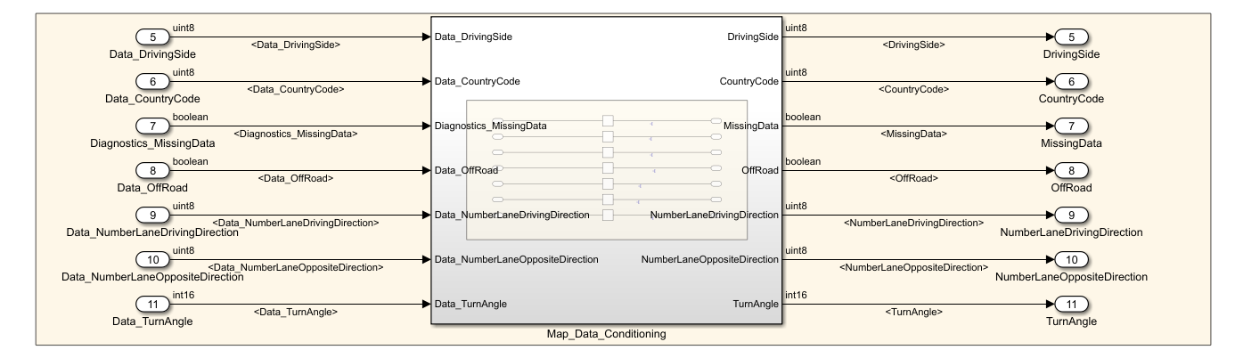

For function requirement 00002/3, vehicle speed needs to be converted from mps to kph and yaw rate from rad/s to deg/s. For this purpose, subsystems Vehicle_Speed_Conversion and Yaw_Rate_Conversion are created. Conversion is done with the help of Gain Block with values specified in the requirement document.

 As per function requirement FUN – REQ – 00004 signals: Data_DrivingSide, Data_CountryCode, Diagnostics_MissingData, Data_OffRoad, Data_NumberLaneDrivingDirection, Data_NumberLaneOppositeDirection, Data_TurnAngle need to be renamed without being undergone any change.

For this purpose, a subsystem named Map_Data_Conditioning is created. As per previous systems, in this system, a slider gain block with value 1 is used for renaming the signals from import to outport.

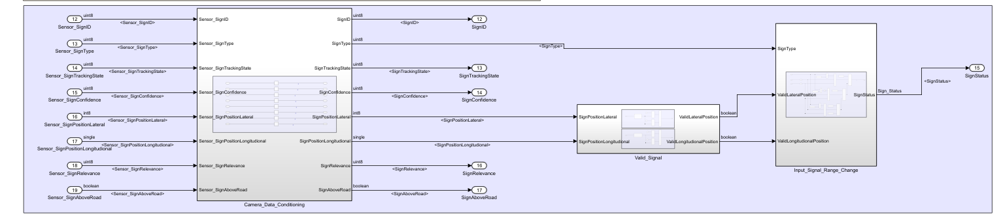

As per requirement FUN – REQ – 00005, signals:Sensor_SignID, Sensor_SignType, Sensor_SignConfidence, Sensor_SignTrackingState, Sensor_SignPositionLateral, Sensor_SignPositionLongitudional, Sensor_SignRelevance, Sensor_SignAboveRoad needs to be renamed without undergone any process. For this purpose, a subsystem named Camera_Data_Conditioning is created. Inside the subsystem, slider gain block with value 1 is used.

 For function requirements FUN – REQ – 00006/7/8/9, two subsystems are developed named Valid_Signal and Input_Signal_Range_Change.

Subsystem Valid_Signals receives its input from Camera_Data Conditioning. This subsystem checks the validity of SignPositionLateral, SignPositionLongitudional. As per requirement document Traffic sign, the lateral position is valid within -60 to +60 while the longitudinal position is valid within range 0 to 255. Inside the Valid_Signal Subsystem, two subsystems are created named Lateral_Sign_Value_in_ISO_Coordinates and Sign_Positional_Longitudional to manipulate the lateral and longitudinal signals. Signal named SignPositionLateral is converted from iso to cartesian coordinates using gain block. Value of gain block is given in the requirement document. Signal named SignPositionLongitudional to need to be processed through slider gain block with value 1 for renaming.

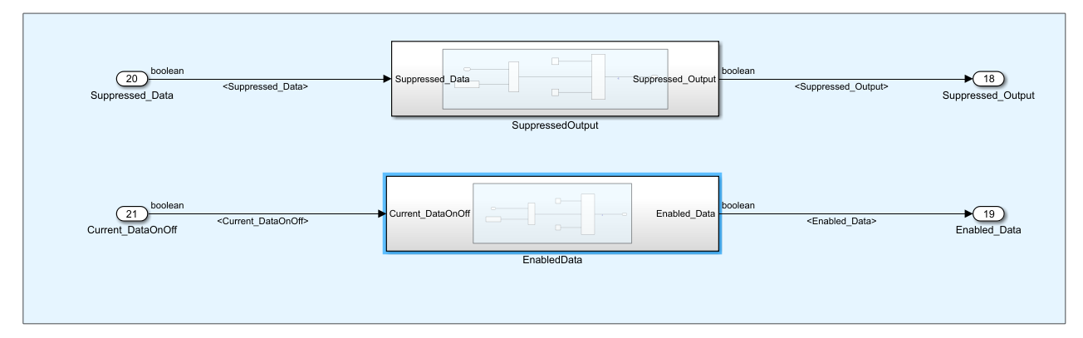

For deciding type of sign i.e reserved, new, updated and invalid, another subsystem is modelled named Input_Signal_Range_Change. It receives its input SignType from Camera_Data_Conditioning subsystem, ValidLateralPosition/ValidLongitudionalPosition from Valid_Signal subsystem. Signal named SignType is compared with calibration values provided in Requirement Document and based on its logical output. If three conditions i.e. comparison with calibration, valid lateral and longitudinal position is satisfied, the signal is tagged as "reserved" else further conditions for status "new", "updated", "invalid" is checked.

For requirements FUN – REQ – 00013/14, two separate subsystems are designed named SuppressedOutput, EnabledData.

Inside subsystem SuppressedOutput, input signal Suppressed_Data is compared with calibration value mentioned in requirement document using relational operator block. If condition satisfies, a Fail signal i.e. 0 passes through else True signal i.e. 1 passes further.

The similar strategy used for designing subsystem EnabledData. If condition satisfies, a True signal i.e. 1 pass further else False signal i.e. 0.

**Step 3:** SLDD Creation and Signal Resolution

Whatever the signals used while designing a model are described in Simulink Data Dictionary. A new SLDD named WWDW_dd.sldd is created and linked with the model. Signal Properties of all signal used are described in SLDD.

Signal properties include signal data type, minimum and maximum values, unit, storage class, header file & definition file names and dimensions. Firstly, alias types are described for all type of data types and then signals and calibration values are specified.

Once the signal being specified in SLDD, next job is to name the important signals in the model. All input and output signals are given their names specified in SLDD. If signals are originating from a block, then these signals should be marked as Simulink signal object. As these signal goes from each subsystem and then blocks, it is marked as a propagated signal in its further process.

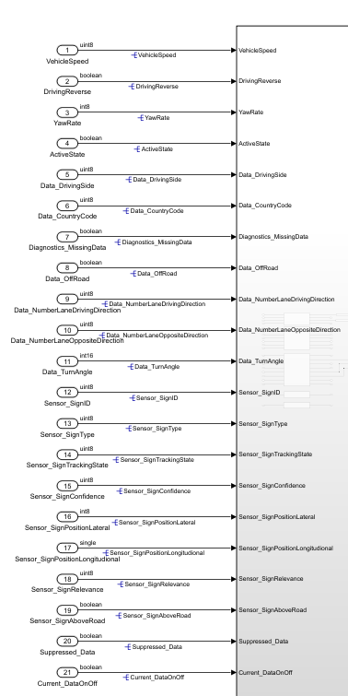

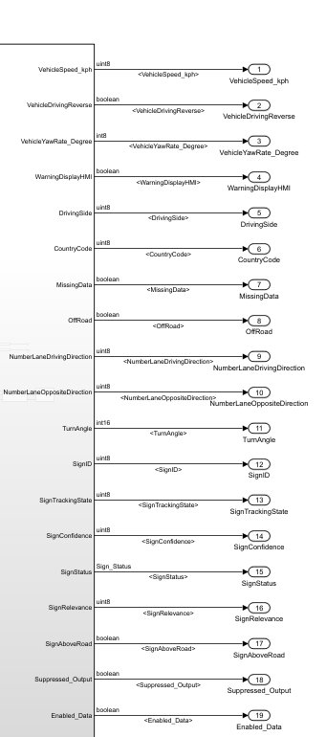

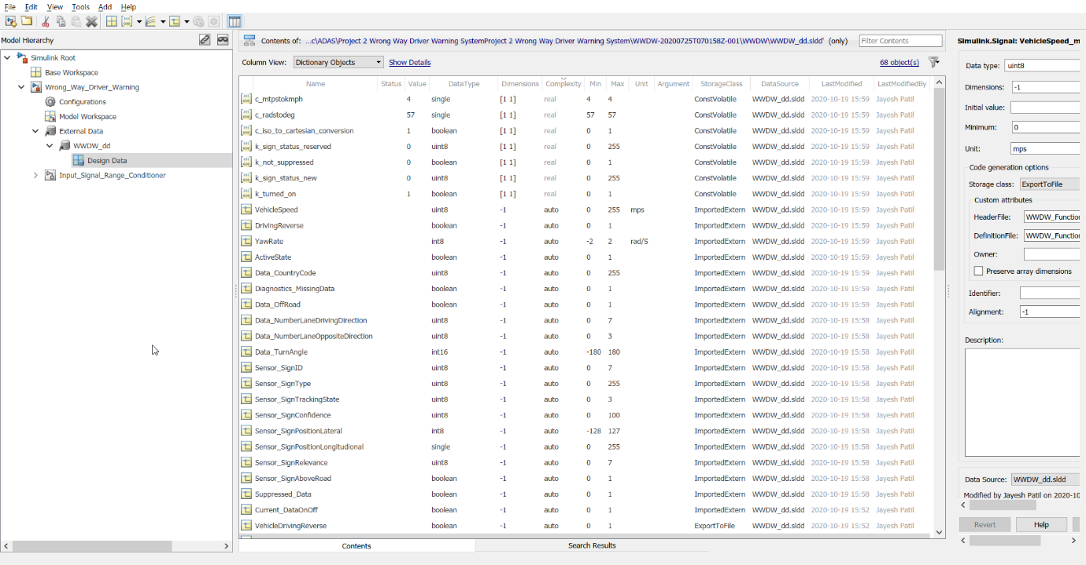

**Step 4:** Model Advisor Check

The Model Advisor checks your model or subsystem for modelling conditions and configuration settings that cause inaccurate or inefficient simulation of the system that the model represents. The Model Advisor checks can help you verify compliance with industry standards and guidelines. By using the Model Advisor, you can implement consistent modelling guidelines across projects and development teams.

Upon completing the analysis of your model, the Model Advisor produces a report that lists the suboptimal conditions, settings, and modelling techniques and proposes solutions, when applicable.

Once the signal being specified in SLDD, next job is to name the important signals in the model. All input and output signals are given their names specified in SLDD. If signals are originating from a block, then these signals should be marked as Simulink signal object. As these signal goes from each subsystem and then blocks, it is marked as a propagated signal in its further process.

Model Advisor Check: Model Advisor Check option is available in Modelling Tab. As the scope of the project is small, the Advisor check is carried out for a few parameters only. Warnings got after running the check are resolved and the final report is generated and saved. The same report is also attached to the project. It is not necessary to resolve all the errors, so important errors are resolved which may hamper the code generation process.

Configuration Parameter Update: Once it is sure that the model doesn't have an error, the model set can be set appropriately. Model Setting option is available under Modelling Tab. All Configuration parameter is set and its images are saved in ppt. The same ppt is attached to this project.

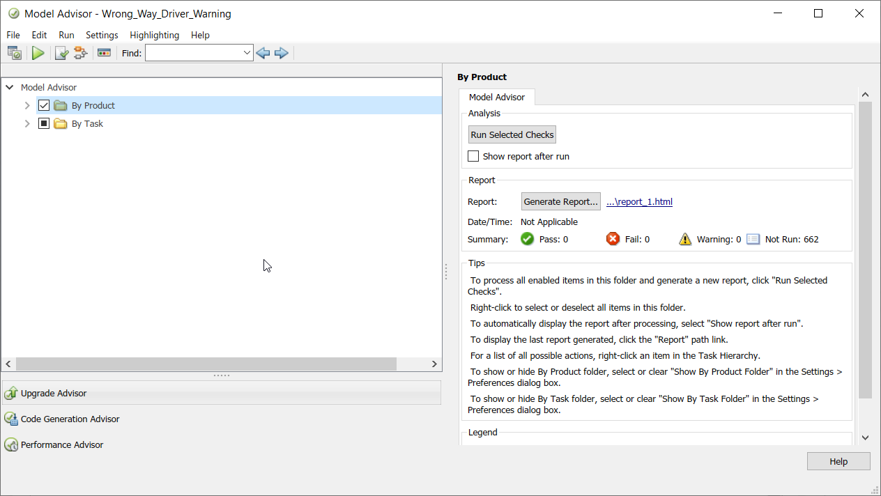

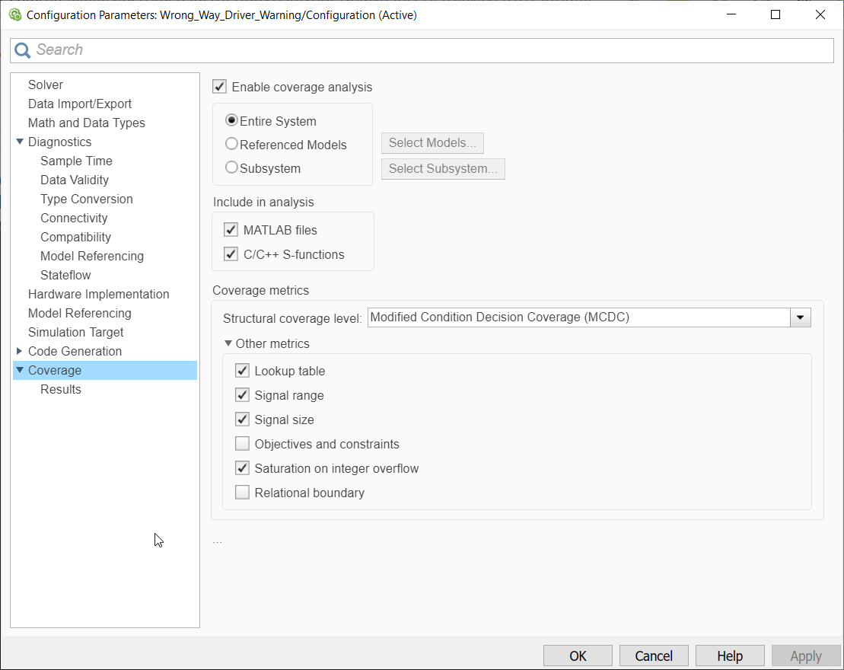

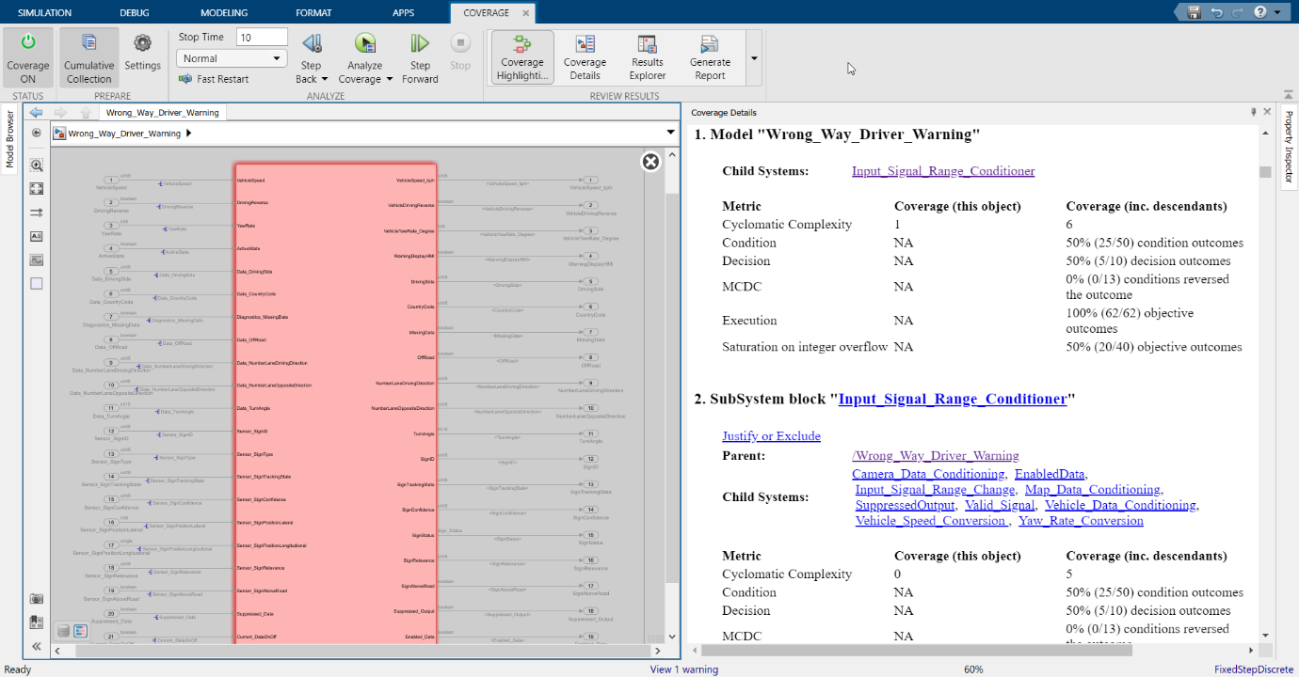

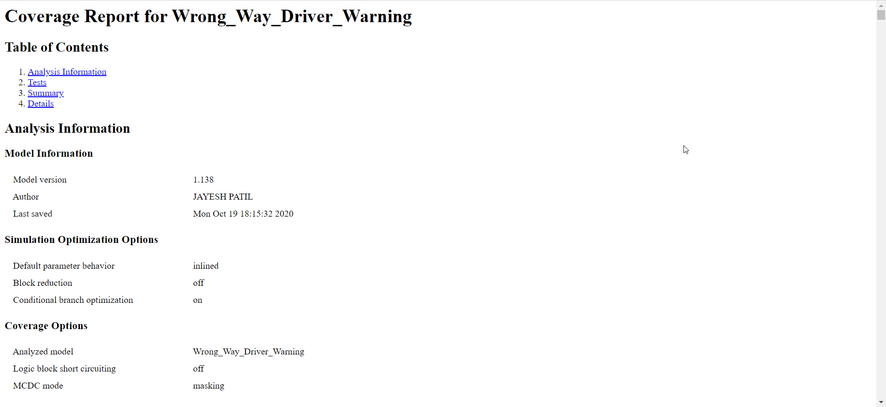

In the model advisor, the model is checked for the following tasks and guidelines,

Modelling Standards for ISO 26262

Modelling Standards for EN 50128

Model Metrics

Code Generation Efficiency

Model Referencing

Modelling Standards for MAB

Modelling Standards for JMAAB

Modelling Standards for MISRA C:2012

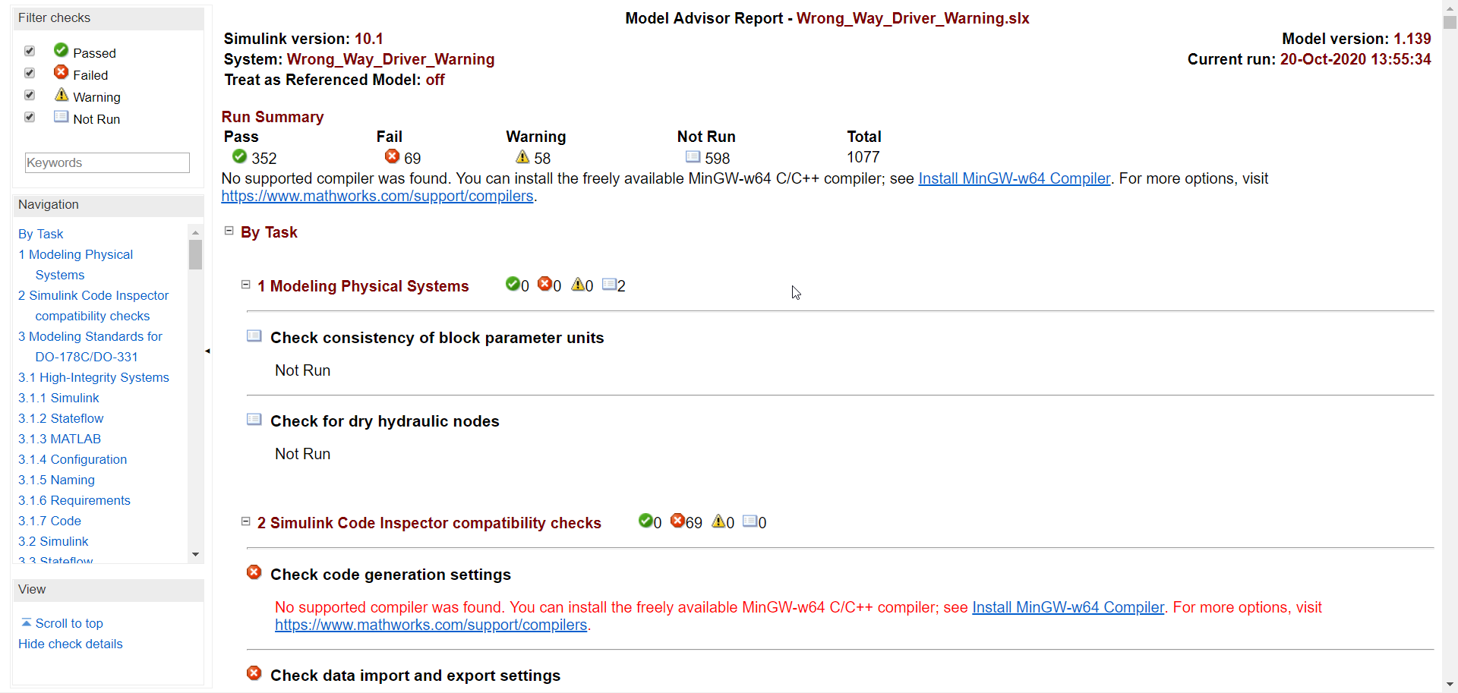

After the model advisor check report, the result was as follows -

**Pass - 352**

**Failed - 69**

**Warnings - 58**

Furthermore, correct some of the error suggested by the model advisor, the model was rechecked, this time the

the number of warnings got reduced and the number of modules that were passed got increased.

**Pass - 349**

**Failed - 0**

**Warnings - 43**

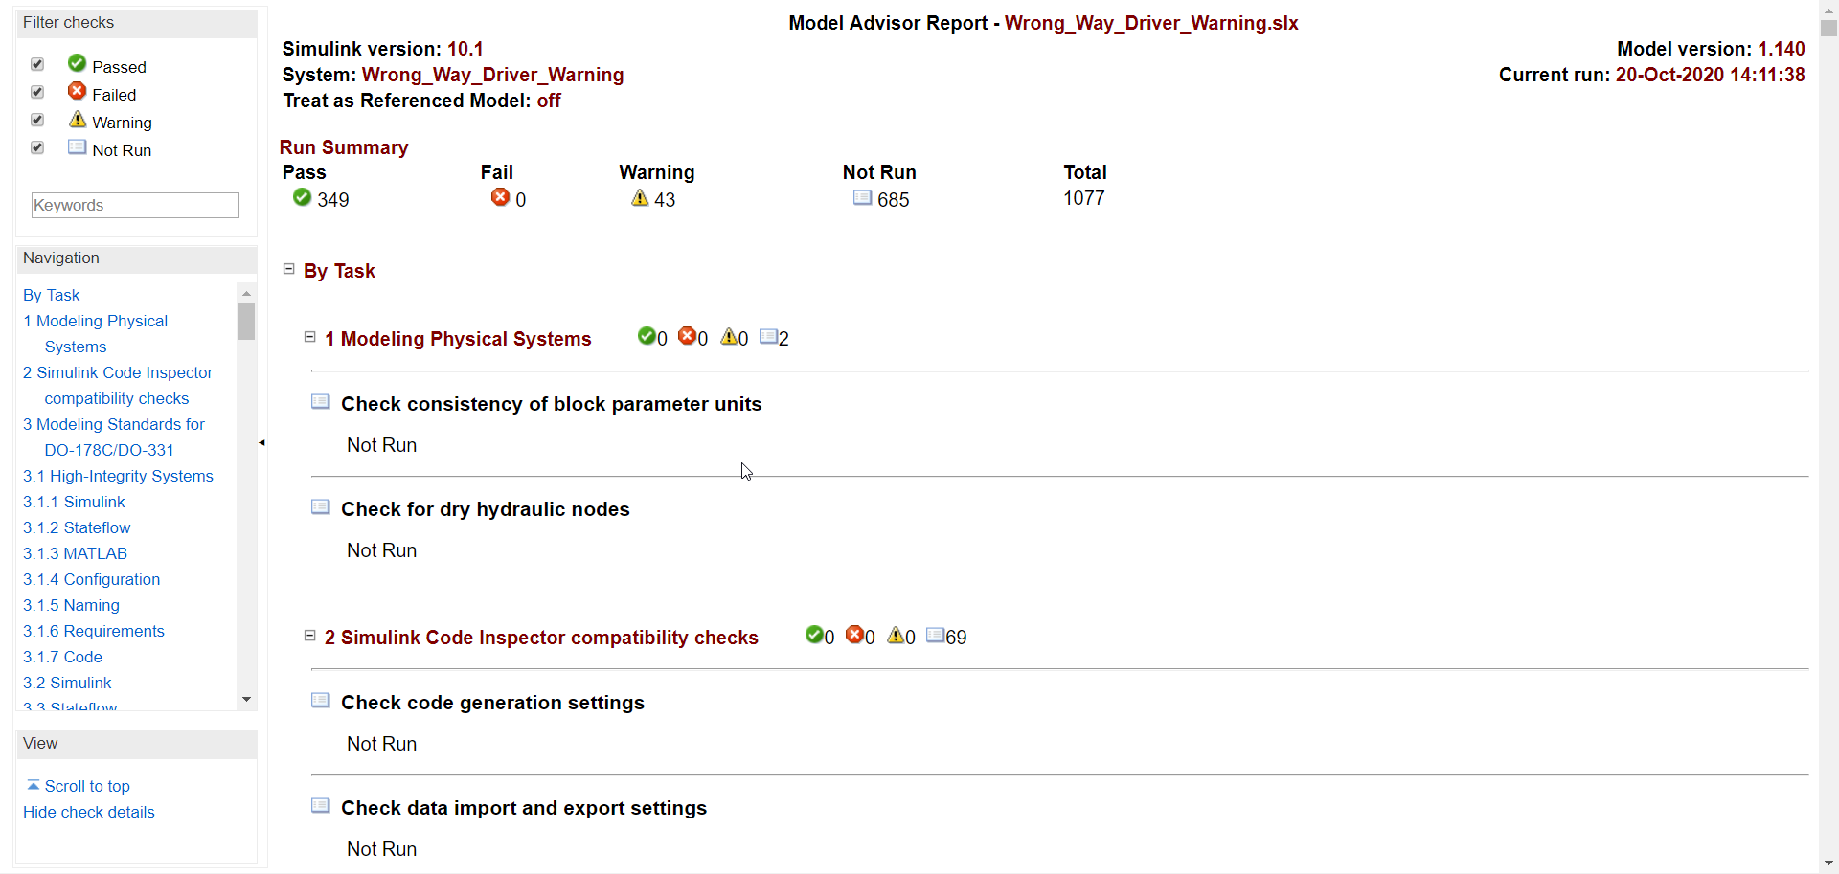

The report is then generated for the given Simulink model.

**Analysis and Results**

**Step 5:** Code Generation

Last Part of the model design is code generation. Once all necessary changes been done as per model advisor, code generation can be started. ctrl+B is a shortcut key to start code generation. After successful completion of the code generation process, c-code is generated for the model created in Simulink.

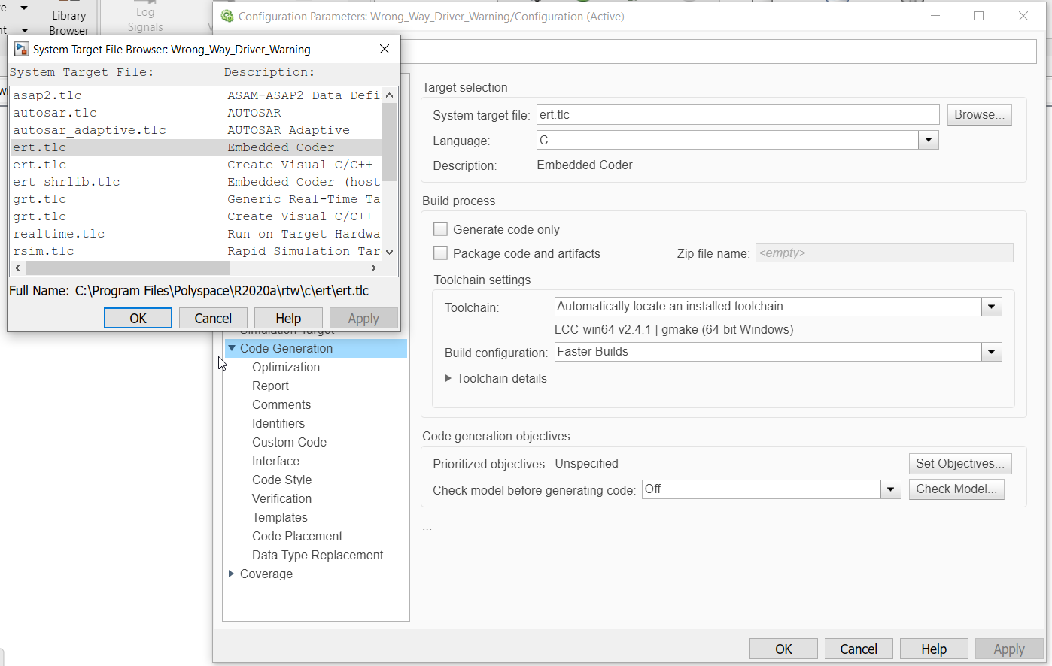

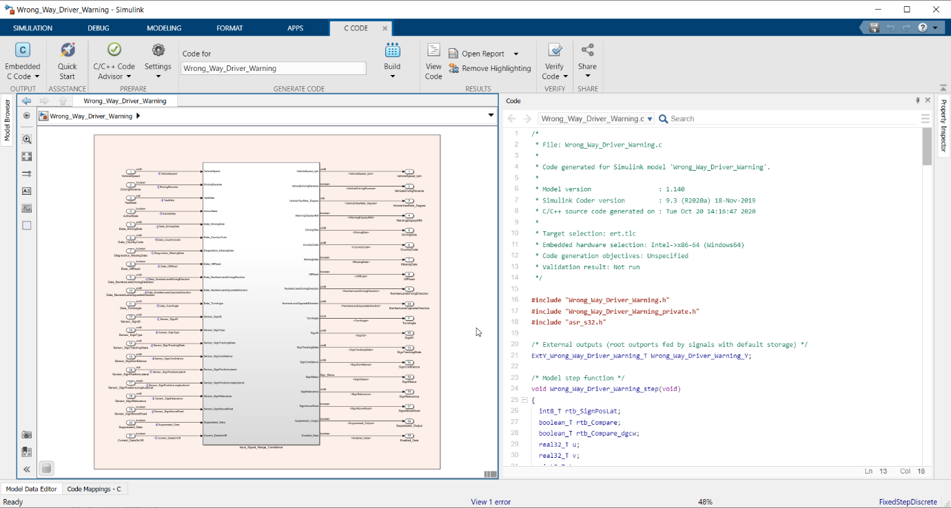

**Code Generation -**

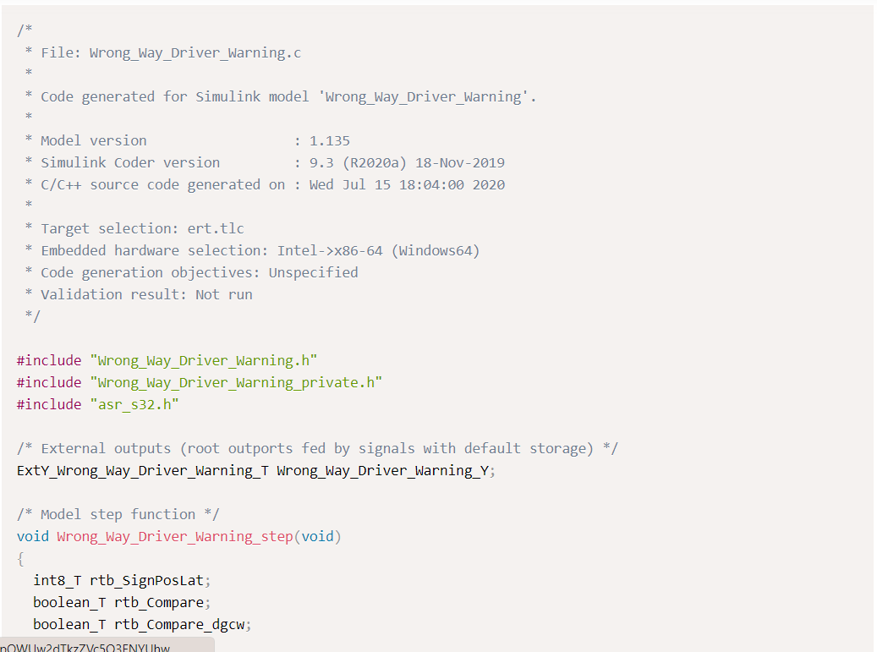

## Conclusion

Requirement Document : Wrong_Way_Driver_Warning_System_Requirement_Document.docx

Model File : Wrong_Way_Driver_Warning_2019b.slx

SLDD File : WWDW_dd.sldd

Model Advisor Report : Model_Advisor_Report.pdf

C File : Wrong_Way_Driver_Warning.c